NAME : KUNAL RAJENDRA BARDE
SUBJECT : COMPUTER NETWORKS

UDP PING ASSIGNMENT

Code for UDP Ping Server :

import java.io.*;

import java.net.*;

import java.util.*;

public class PingServer

{

private static final double LOSS_RATE = 0.3;

private static final int AVERAGE_DELAY = 100; //milliseconds

public static void main(String args[]) throws Exception

{

if(args.length!=1)

{

System.out.println("Required Arguments: Port");

return;

}

int port = Integer.parseInt(args[0]);

Random random = new Random();

DatagramSocket socket = new DatagramSocket(port);

while(true){

DatagramPacket request = new DatagramPacket(new byte[1024],1024);

socket.receive(request);

printData(request);

if(random.nextDouble()<LOSS_RATE){

System.out.println("Reply not sent.");

continue;

}

Thread.sleep((int) (random.nextDouble()*2*AVERAGE_DELAY));

InetAddress clientHost = request.getAddress();

int clientPort = request.getPort();

byte[] buf = request.getData();

DatagramPacket reply = new DatagramPacket(buf, buf.length, clientHost, clientPort);

socket.send(reply);

System.out.println(" Reply Sent ");

}

}

private static void printData(DatagramPacket request )throws Exception

{

byte[] buf = request.getData();

ByteArrayInputStream bais = new ByteArrayInputStream(buf);

InputStreamReader isr = new InputStreamReader(bais);

BufferedReader br= new BufferedReader(isr);

String line = br.readLine();

System.out.println("Received from"+request.getAddress().getHostAddress()+":"+new String(line));

}

}

Code for UDP Ping Client :

import java.util.*;

import java.net.*;

import java.text.*;

public class PingClient

{

private static final int PING_MESSAGES = 10; //10 Ping Requests to be made to the server

private static final int TOKEN_TIMESTAMP = 2; //Time stamp indicating the time the ping was requested to the time it was sent back

private static final int MAX_WAIT_TIME = 1000; //Timeout : The time to wait till the state indicates a timeout

static int i;

public static void main(String args[])throws Exception

{

if(args.length!=2)

{

System.out.println("Please enter both Host and Port IP Adresses as : java PingClient Host Port");

return;

}

try

{

if(!args[0].isEmpty())

System.out.println("\n Host:"+args[1]+"\n IP Address:"+args[0]+"\n");

}

catch(ArrayIndexOutOfBoundsException e)

{

System.out.println("Please input Host name and IP Address");

System.exit(1);

}

InetAddress host = InetAddress.getByName(args[0]);

int portNumber = Integer.parseInt(args[1]);

DatagramSocket socket = new DatagramSocket(); //Creating a Datagram socket for sending and receiving UDP Packets

socket.setSoTimeout(MAX_WAIT_TIME);

for(int i=0;i<PING_MESSAGES;i++) //Creating Ping Messages to be sent to the server

{

String message = generatePing(i);

DatagramPacket ping_request = new DatagramPacket(message.getBytes(), message.length(), host, portNumber);

socket.send(ping_request); //Sending ping request to the server

DatagramPacket ping_response = new DatagramPacket(new byte[message.length()],message.length()); // Store server response in a Datagram packet

try

{

socket.receive(ping_response);

Output(ping_response);

}

catch(SocketTimeoutException e)

{

System.out.println("No response received from the server");

}

catch(Exception e)

{

e.printStackTrace();

return;

}

}

}

private static String generatePing(int sequence_num)

{

SimpleDateFormat sdf = new SimpleDateFormat("MM/DD/YYYY HH:MM:SS");

String strTime = sdf.format(new Date(System.currentTimeMillis()));

return "PING : "+ i + " " + System.currentTimeMillis()+"("+strTime+")";

}

private static void Output(DatagramPacket request) throws Exception

{

String response = new String(request.getData());

String[] tokens = response.split(" ");

long sent_timestamp = new Long(tokens[2]);

long received_timestamp = System.currentTimeMillis();

long rtt = received_timestamp - sent_timestamp;

System.out.print(response+ "Received From"+request.getAddress().getHostAddress()+" "+"(RTT="+rtt+ "ms)"+"\r\n");

}

}

Output :

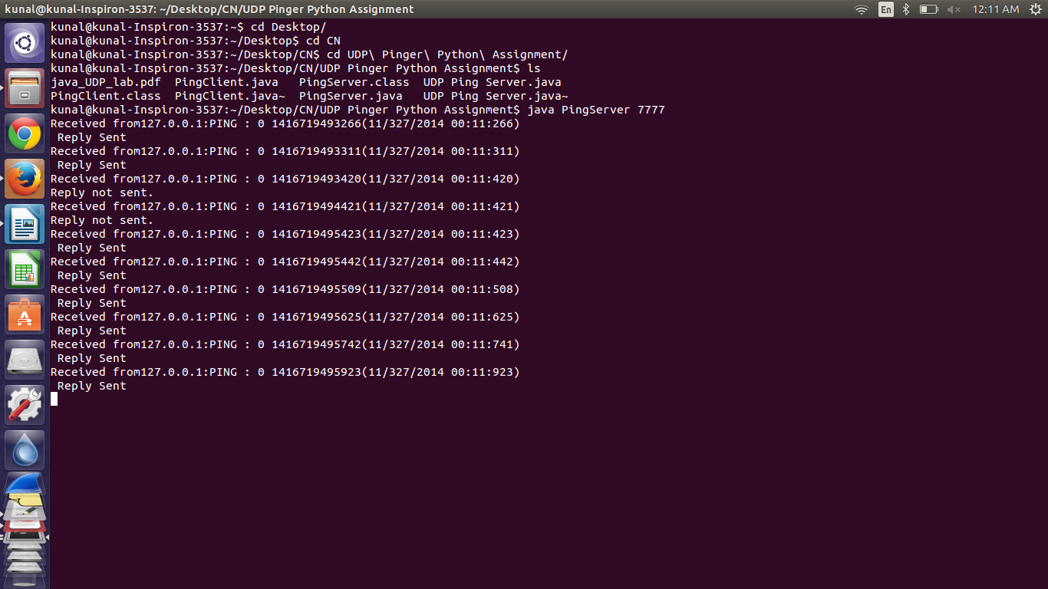
UDP Server Running

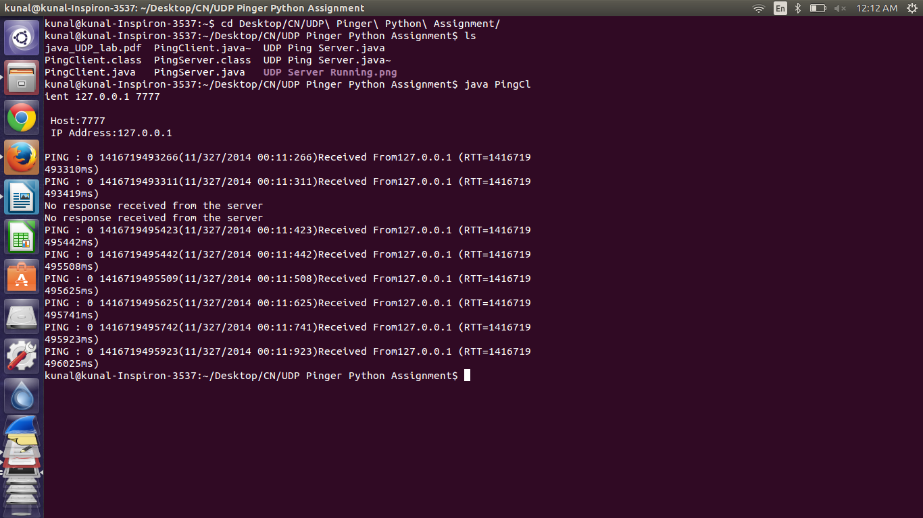
UDP Client Running

